# POWER BI (Business Intelligence)

**Install Power BI Desktop**: -> Microsoft Store

**Update Power BI Desktop**: -> File -> Options and Settings -> Preview Fields -> Mark necessary checkboxes and restart the application.

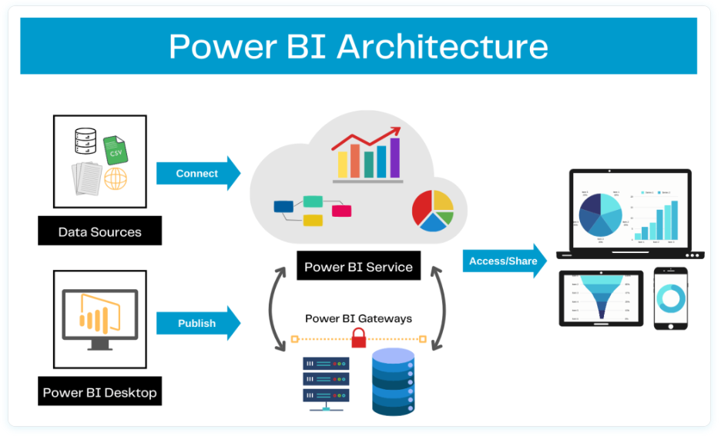

## Introduction to Power BI

**Power BI is a business intelligence (BI) and data visualization tool developed by Microsoft. It allows users to connect to various data sources, transform raw data, and create interactive reports and dashboards to gain insights. Power BI is widely used for data analysis, reporting, and decision-making.**

### Power BI Desktop

* A **Windows application** used for creating reports and dashboards.
* Provides features like **data modeling, visualization, and DAX (Data Analysis Expressions)**.

### Power BI Service (Power BI Online)

* A **cloud-based platform** where users can publish, share, and collaborate on Power BI reports and dashboards.
* Enables **automatic data refresh** and integration with other Microsoft services (e.g., Excel, Azure).

### Supporting Components of Power BI

**Power Query**

* A data transformation tool that allows users to clean, reshape, and combine data before analysis.

**Power Pivot**

* A data modeling component for creating relationships and measures using **DAX (Data Analysis Expressions)**.

**Power View**

* The visualization layer where users design interactive reports with charts, graphs, and KPIs.

**KPIs in Power BI are just visual indicators** that help track performance and data consistency. They **don’t change the data** but make it easier to understand whether you are meeting your goals.

## Basic Charts in Power BI Desktop

### Column Chart

### Stacked Column Chart

### Pie Chart **Basic Charts**

### Donut Chart

### Funnel Chart

### Ribbon Chart

### Include and Exclude:

It works like a filter where we can select multiple data points and make a separate view from the selected values.

### View data and Export:

Select customized data -> Right click -> click on (show data point as a table) -> click on three dots located at the right top corner -> click on export data.

We can also restrict the end user to do this operation of exporting data in settings field.

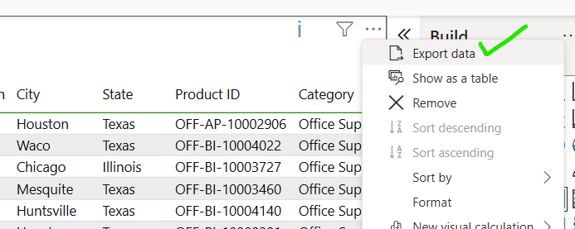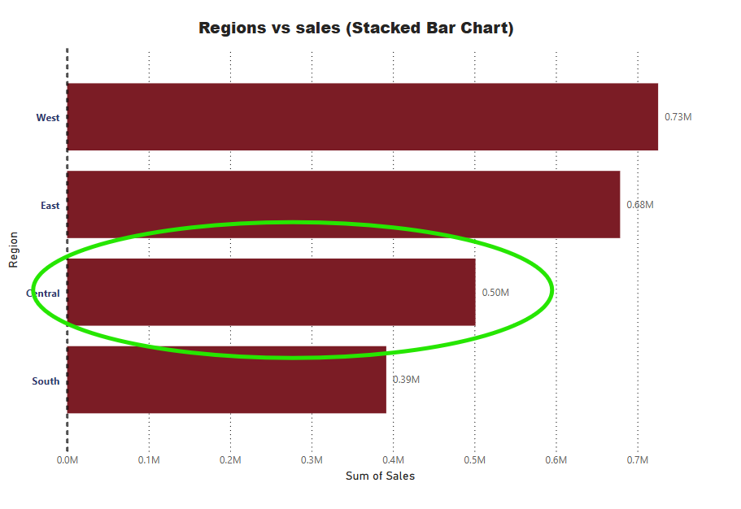

### Map

## Table and Matrix in PowerBI

### Creating a Simple Table

### Formatting in Table

### Conditional Formatting in Table

### Creating a Matrix in Power BI **Table and Matrix**

### Conditional Formatting in PowerBI

### Automatic Formatting in PowerBI

### Sub Total and Grand Total

### Number Formatting in Table and Matrix

## Other Charts in PowerBI Desktop

### Line Chart

### Drill Down in Line Chart

### Area Chart

### Line vs Column Chart

### Scatter Plot Other Charts

### Waterfall chart

### TreeMap

### Guage Chart

## Cards and Filters

### Number Card

### Text Card

### Date Card

### Multi-Row Card Cards and Filters

### Filter on Visual

### Filter on Page

### Filter on All Pages

### Drill Through

## Slicers in PowerBI Desktop

### Slicer For Text

### Format Text Slicer

### Data Slicer Slicers

### Format Data Slicer

### Number Slicer

## Advanced Charts in PowerBI

### Animated Bar Chart Race

### Drill Down Donut Chart

### Drill Down Column Chart

### Word Chart

### Sankey Chart

### Infographic

### Play Axis

### Scoller

### SunBurst Chart

### Histogram

## Insert Tab Operations

### Insert Images, Objects

### Creating Index page to navigate to the other pages

### Bookmark action

### Drillthrough Action

## Power BI Service Introduction

### Creating a SuperStore Report

### Create an account PowerBi service

### Publish Report to Power BI Service Account

### Export (PPT, PDF, PBIX) Report and Share

### Comment, Share and Subscribe to a report

### Create a Dashboard in a powerBI service

### Problem in PowerBI Dashboard and its solution

### Automatic Refresh – Data Gateway

### Create Report Directly in Power Bi service